IOT Enabled Risk Monitoring System for Cold Supply Chain

**Team Members**

Amrutha MS - 20BCE1665

Sakshi Singh - 20BCE1324

Vaishnavi JS - 20BCE1571

Navya Kala SV - 20BCE1858

Amritansh Anand - 20BCE1650

Guide

Geetha S

**School name:** ​School of Computing Science and Engineering

**Faculty name (ERP No):**​ Geetha S (50587)

**Academic Year:**​ 2022-2023 (Winter Semester 22-23)

**Title of the project:**​ IOT Enabled Risk Monitoring System for Cold Supply Chain

**Number of students involved in this project:** ​5

   Amrutha MS Vaishnavi JS Amritansh Anand  

Sakshi Singh Navya Kala SV

Table of Content

**Chapter 1: Introduction 5**

1.1 Abstract 5

1.2 Problem Definition 5

1.3 Motivation 6

**Chapter 2 Methodology** **7**

2.1 Project Component Specification 7

2.2 Construction 11

**Chapter 3 Architecture**  **13**

3.1 Architecture Diagram  13

3.2 Class Diagram  13

3.3 Activity Diagram 14

3.4 Use Case Diagram  15

3.5 Sequence Diagram 15

3.6 3-D Visualisation 16

3.7 Solution to the problem statement 16

**Chapter 4 Implementation**  **17**

4.1 Temperature and Humidity Module 17

4.2 GPS Module 18

4.3 Gas Sensor Module  21

4.4 PIR Sensor Module  22

4.5 Keypad-Interfacing Module  23

**Chapter 5: Results**   **25**

**Chapter 6: Outcomes**  **26**

**Chapter 7: Single Unique Factor**   **26**

**Chapter 8: Site Visit**   **27**

**Chapter 9: Sample Codes**   **27**

**Chapter 10: References**   **27**

List of Symbols

**SYMBOL EXPLANATION**

IOT Internet of Things

LED Light-emitting diode

PIR Passive infrared

ESP Electrostatic Precipitator

LPC Low Power Consumption

IR Infrared sensor

GPS Global Positioning System

MCU Microcontroller

Chapter 1: Introduction

Abstract:

The cold supply chain is a vital component of the global supply chain network, where temperature-controlled products such as pharmaceuticals, vaccines, and perishable foods are transported from one place to another. However, any deviation from the required temperature range can lead to significant damage, resulting in financial losses, compromised quality, and public health risks. To mitigate these risks, an IoT-enabled risk monitoring system for the cold supply chain has been developed. The proposed system comprises various modules, including PIR & GAS Sensor, Camera, Stepper Motor, ESP8266 Wi-Fi Module, Keypad Interfacing, Humidity Info, Temperature Info, and LPC2148 & LPC1768. These modules work together to continuously monitor the environment, send real-time data to a cloud-based platform, analyze the data, and alert stakeholders in case of any deviations from the required temperature range. The system's advanced features, such as real-time tracking of vehicles and automatic route optimization, make it an essential tool for any organisation involved in the cold supply chain.

Problem Definition:

Transporting temperature-sensitive products requires strict temperature control to maintain their quality and prevent damage. However, monitoring the environment and maintaining the temperature range throughout the supply chain can be challenging. Traditional temperature monitoring methods are often manual and prone to errors, leading to significant financial losses and public health risks. Moreover, there is a lack of real-time data and alerts, which can lead to delayed action and potential damage to the products. To address these challenges, an automated system is needed that can continuously monitor the temperature and humidity of the environment, identify any deviations, and alert stakeholders in real-time.

Motivation:

The IoT-enabled risk monitoring system for the cold supply chain aims to provide a comprehensive solution to the challenges faced in monitoring temperature-controlled products' transportation and delivery. The proposed system utilizes advanced modules, such as PIR & GAS Sensor, Camera, Stepper Motor, ESP8266 Wi-Fi Module, Keypad Interfacing, Humidity Info, Temperature Info, and LPC2148 & LPC1768, to provide accurate and real-time data, enabling stakeholders to take immediate action and prevent any potential damage. The system's advanced features, such as automatic route optimization, real-time tracking of vehicles, and user-friendly dashboard, make it an essential tool for any organisation involved in the cold supply chain.

The motivation behind the system is to ensure the safe transportation and delivery of temperature-controlled products while maintaining their quality and preventing financial losses and public health risks. With the help of IoT sensors, the system continuously monitors the temperature and humidity of the environment and sends real-time data to a cloud-based platform, where it is analysed using machine learning algorithms to identify any deviations from the required temperature range. The system then sends alerts to the relevant stakeholders in case of any deviations, allowing them to take immediate action and prevent any potential damage. The system's user-friendly dashboard provides stakeholders with easy access to real-time data, analytics, and reports, enabling them to make data-driven decisions and optimise their operations.

In conclusion, the IoT-enabled risk monitoring system for the cold supply chain offers a comprehensive solution to mitigate the risks associated with temperature-controlled products' transportation and delivery. The system's ability to provide real-time data, alerts, and insights, coupled with its advanced features, makes it an essential tool for any organisation involved in the cold supply chain. By ensuring the safe transportation and delivery of temperature-controlled products, the system can prevent financial losses, compromised quality, and public health risks.

Chapter 2: Methodology

2.1 Project Component Specification

| **S. No.** | **PRODUCT** | **PRODUCT SPECIFICATION** | **USE CASE** |
| --- | --- | --- | --- |
| 1 | Esp 8266 wifi module | The Wi-Fi module is responsible for connecting the system to the internet and sending real-time data to a cloud-based platform. | Control home automation devices over the internet. |
| 2 | Temperature sensor | The temperature sensor is used to measure the temperature of the environment and detect any deviations from the required temperature range. | Monitor the temperature inside a refrigerator. |
| 3 | Humidity sensor | The humidity sensor is used to measure the humidity of the environment and detect any deviations from the required humidity range. | Control the humidity levels in a greenhouse. |
| 4 | IR Sensor | The IR sensor is used to detect any objects in front of the system and activate the stepper motor to open or close the gas valve. | Control a TV or other electronic devices with a remote control. |
| 5 | PIR Sensor | The PIR sensor is used to detect any movement in the environment and send an alert to the cloud-based platform. | Trigger a security camera when motion is detected. |
| 6 | GPS module | The GPS module is used to track the location of the vehicles involved in the cold supply chain. | Track the location of a delivery truck. |
| 7 | Keypad interfacing | The keypad interfacing is used to enter any necessary information or commands into the system. | Unlock a door with a passcode. |
| 8 | Display | The display is used to show relevant information, such as temperature, humidity, and alerts. | Show the current time on a digital clock. |
| 9 | Arduino Uno | The Arduino Uno is used as the main microcontroller for the system. | Control a robot arm. |
| 10 | Jumper wires | Jumper wires are used to connect the various components of the system. | Connect a breadboard to an external circuit. |
| 11 | Breadboards | Breadboards are used to prototype and test the system before finalizing the design. | Prototype a circuit for a new electronic gadget. |
| 12 | Stepper motor | The stepper motor is used to open or close the gas valve based on the readings from the IR sensor. | Control the movement of door. |
| 13 | Gas valves | The gas valves are used to control the flow of gas into the refrigeration unit. | Control the flow of gas in cold storage. |
| 14 | Buzzer | The buzzer is used to sound an alarm in case of any deviations from the required temperature or humidity range. | Alert the user when a timer has finished. |
| 15 | Node mcu | The Node MCU is an alternative Wi-Fi module that can be used in place of the ESP8266. | Monitor the temperature and humidity levels in a remote location. |
| 16 | Relay module | The relay module is used to control the stepper motor and gas valve. | Control a garage door opener. |
| 17 | LED -Red green yellow | The LEDs are used to indicate the status of the system, such as whether it is connected to Wi-Fi or if there are any alerts. | ndicate the status of a home security system. |
| 18 | Resistors | Resistors are used to limit the current flowing through various components of the system. | Limit the current to an LED to prevent it from burning out. |
| 19 | Capacitor | Capacitors are used to filter out any noise or interference in the system. | Store energy in a camera's flash capacitor. |

2.2 Construction

2.2.1 System Features Surveillance

*Description and Priority:* The project has a included 360 degrees camera for surveillance and security purposes.It provides an additional layer of security to the facility along with a means to keep track of all the people and goods moving in and out of the facility.The records are stored for future purposes in case any need arises to analyze or look through some information held in the records.

*Stimulus/Response Sequences:* Maintaining records of footages and checking for inconsistencies when a security risk occurs.

*Functional Requirements:* Requires camera for visual supervision for security pursoses .It uses Blynk app to store the records of the camera for future needs or if some analysis is required on them.

2.2.2 Person detection for the functioning of gates

Description and Priority: The PIR sensor placed at the gate of the rooms detects if there is a person or not, in case it detects a person, it opens the gate for them to move inside.

Stimulus/Response Sequences: Gate is controlled entirely by the detection of people using the PIR sensor, thus the response to the detection of a person is to open the gate and if the person is not detected anymore the gate is closed.

Functional Requirements: It requires basic functioning of the PIR sensor and its commands given through arduino programming.

2.2.3 Room status and entry access

Description and Priority: It consists of a 2x2 keypad interfacing which helps in assisting to open the door of the room which we wish to enter and also displays the status of the room with the help of LCD display.

Stimulus/Response Sequences: The opening and closing of the door and displaying the status of the room are based on the input we give through the keypad.

Functional Requirements: It requires arduino programming to set up commands for various buttons of the keypad to function properly.

2.2.4 Sensors functioning

Description and Priority: Temperature, humidity, and gas sensors work continuously to monitor and sense any variations in the standard values we set for the room. Triggering buzzer in case of gas leakage or dropping in set values of temperature or humidity.

Stimulus/Response Sequences: Displaying the current values of the temperature, humidity, and gas sensors in the room using an LCD display and triggering the buzzer in case of gas leakage.

Functional Requirements: It requires arduino programming to set up commands for various sensors in each room along with buzzer workings.

2.2.5 Working of gas valve

Description and Priority: If there is a variation in the gas sensor’s values and the buzzer is triggered, then the gas valve is used to stop the gas leakage.

Stimulus/Response Sequences: Opening and closing of the gas valve is controlled based on the occurrence of gas leakage. Gas valve functions with the help of stepper motor and it is common for all the rooms, thus if there is a gas leakage then gas flow will be cut off to all the rooms.

Functional Requirements: It requires arduino programming to set up commands for operating of the gas valve through the stepper motor.

Chapter 3: Architecture

*Architectural Diagram of project:* The basic structure of the project looks like this.

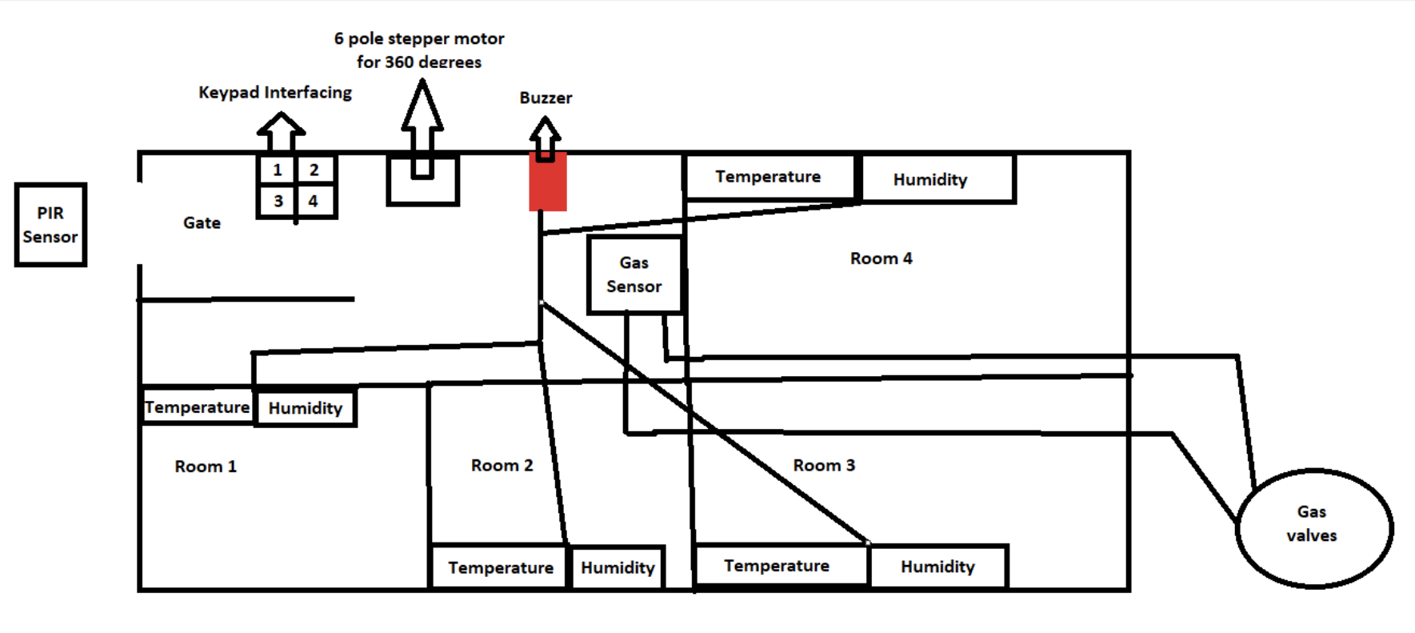

*Class Diagram*

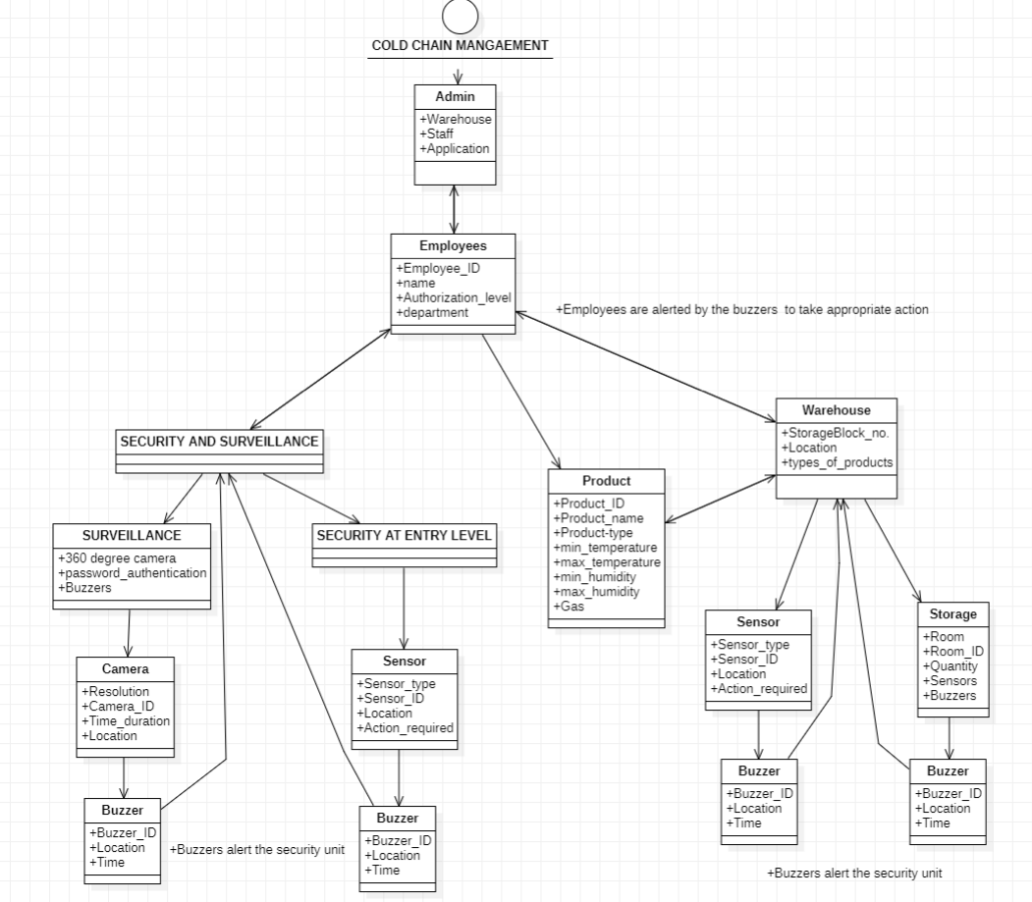

This diagram tells us about the relationship between different classes . The admin (who owns the warehouse) employs the employees who manage all the activities in the warehouse and are in charge of surveillance . The temperature, gas and humidity sensors will activate the buzzer if any anomaly is detected and the employees are alerted through our application software.

*Activity Diagram*

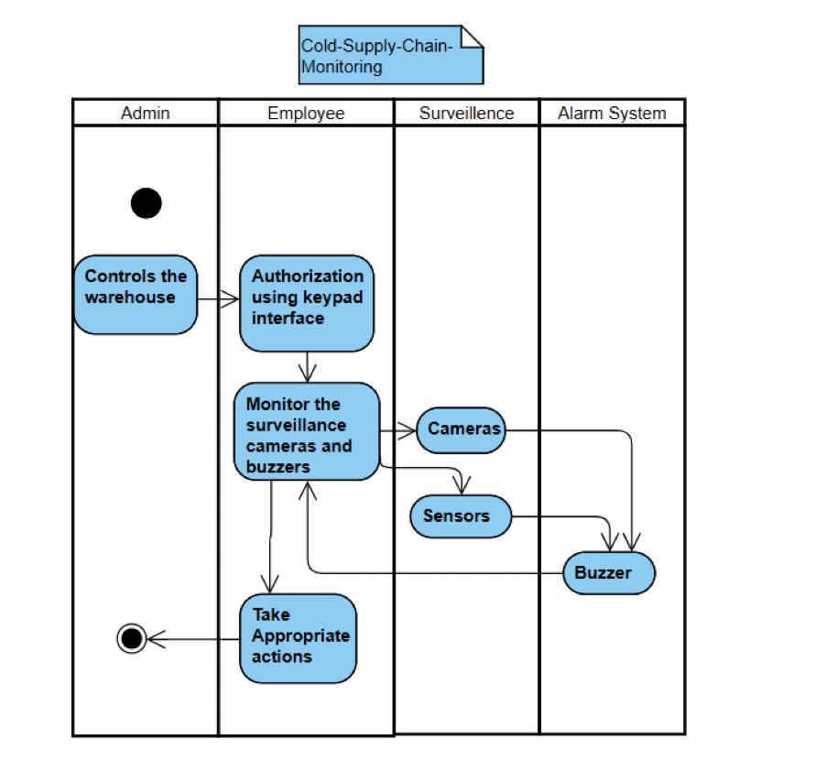

The figure tells us about the activities which will be taking place.

*Use Case Diagram*

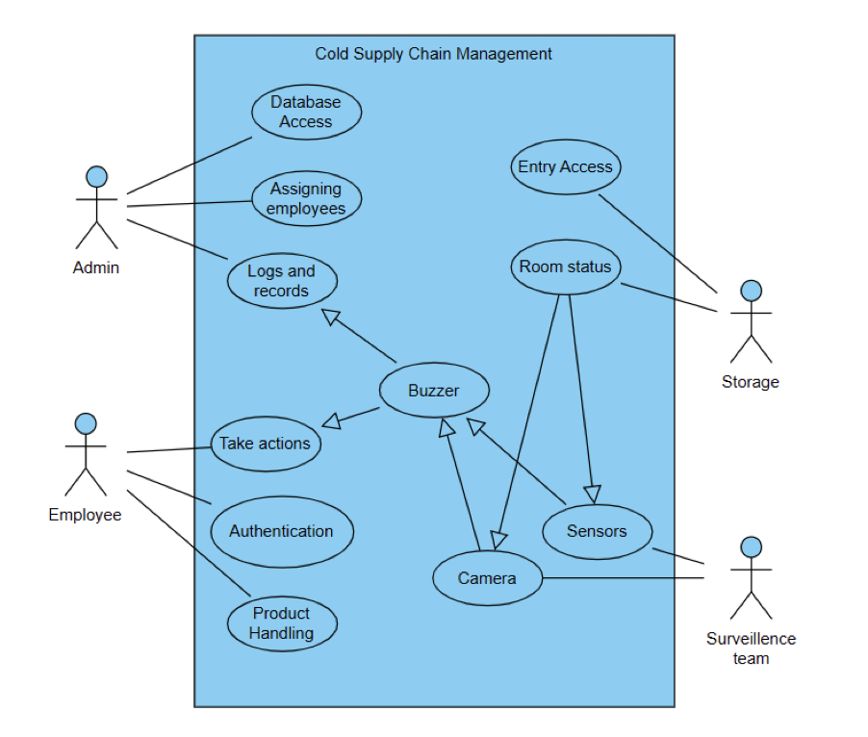

This diagram depicts the external view of the system and represents the interactions between the actors.

*Sequence Diagram:*

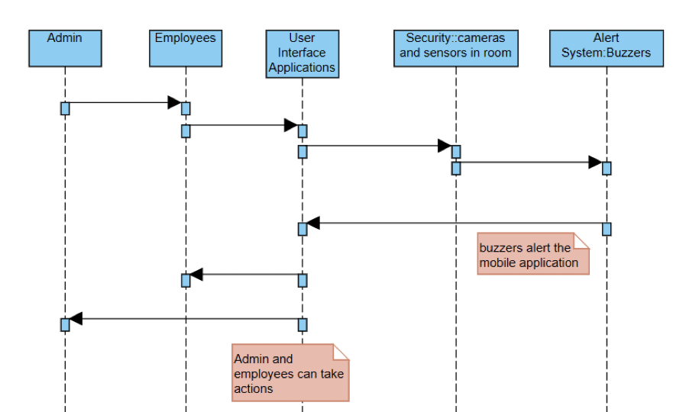

Sequence Diagrams show elements as they interact over time and they are organized according to object (horizontally) and time (vertically).

*3-D Visualization of our Project:*

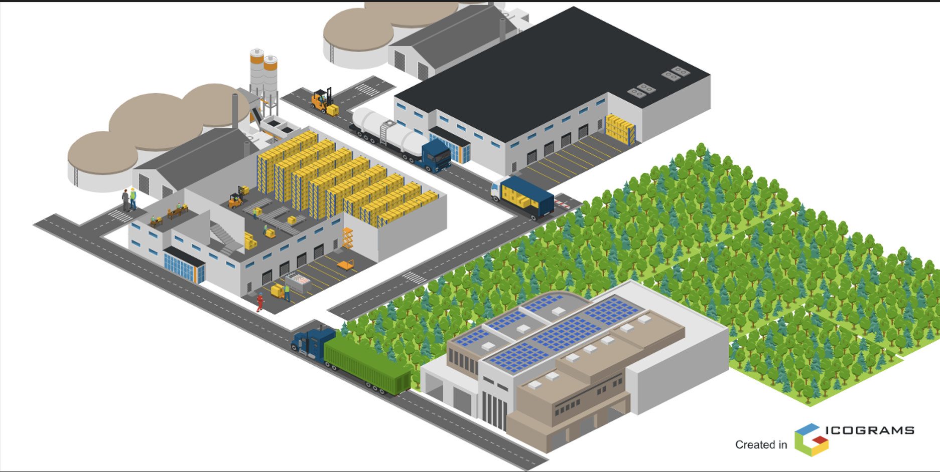

This diagram here gives us an idea about what our warehouse will look life if it is implemented in real life.

This is a cross-sectional view of our storage area(the roof of one block is uncovered to show how it’ll look from the inside). There are tanks filled with gasses which help in cooling. Typical refrigerant gases include carbon dioxide, ammonia, and hydrocarbons such as propane, isobutane and propylene. The admin block which controls all the functions is situated at the front. We can also see the transport vehicles around our warehouse.

*Solution to the problem statement:*

1. Maintenance and periodic check up of temperature, humidity and gas levels in the rooms.
2. Automated operation of gates based on detection.
3. Operation of doors through keypad interfacing.
4. Working of buzzer and gas valves in case of gas leakage.
5. Surveillance and security of cold storage using cameras made with stepper motors.
6. Detection of stored item spoilage.

Chapter 4: Implementation

**Temperature and Humidity Module**

#include <DHT.h>

#define DHT11PIN 14

#define DHTTYPE DHT11

DHT dht(DHT11PIN, DHTTYPE);

float h,tc,tf;

void setup()

{

delay(200);

Serial.begin(9600);

dht.begin();

delay(1000);

Serial.println("DHT11 Temperature and Humidity ");

}

void loop()

{

delay(5000);

h = dht.readHumidity();

tc = dht.readTemperature();

tf = dht.readTemperature(true);

Serial.print('\n');

Serial.print("Humidity = ");

Serial.print(h);

Serial.print("%, ");

Serial.print("Temperature = ");

Serial.print(tc);

Serial.print("°C, ");

Serial.print(tf);

Serial.println("°F");

}

**GPS Module**

#include <TinyGPS++.h>

#include <SoftwareSerial.h>

#include <ESP8266WiFi.h>

TinyGPSPlus gps;

SoftwareSerial SerialGPS(4, 5);

const char* ssid = "Tris";

const char* password = "hestiatrial";

float Latitude , Longitude;

int year , month , date, hour , minute , second;

String DateString , TimeString , LatitudeString , LongitudeString;

WiFiServer server(80);

void setup()

{

Serial.begin(9600);

SerialGPS.begin(9600);

Serial.println();

Serial.print("Connecting");

WiFi.begin(ssid, password);

while (WiFi.status() != WL_CONNECTED)

{

delay(500);

Serial.print(".");

}

Serial.println("");

Serial.println("WiFi connected");

server.begin();

Serial.println("Server started");

Serial.println(WiFi.localIP());

}

void loop()

{

while (SerialGPS.available() > 0)

if (gps.encode(SerialGPS.read()))

{

if (gps.location.isValid())

{

Latitude = gps.location.lat();

LatitudeString = String(Latitude , 6);

Longitude = gps.location.lng();

LongitudeString = String(Longitude , 6);

}

if (gps.date.isValid())

{

DateString = "";

date = gps.date.day();

month = gps.date.month();

year = gps.date.year();

if (date < 10)

DateString = '0';

DateString += String(date);

DateString += " / ";

if (month < 10)

DateString += '0';

DateString += String(month);

DateString += " / ";

if (year < 10)

DateString += '0';

DateString += String(year);

}

if (gps.time.isValid())

{

TimeString = "";

hour = gps.time.hour()+ 5; //adjust UTC

minute = gps.time.minute();

second = gps.time.second();

if (hour < 10)

TimeString = '0';

TimeString += String(hour);

TimeString += " : ";

if (minute < 10)

TimeString += '0';

TimeString += String(minute);

TimeString += " : ";

if (second < 10)

TimeString += '0';

TimeString += String(second);

}

}

WiFiClient client = server.available();

if (!client)

{

return;

}

//Response

String s = "HTTP/1.1 200 OK\r\nContent-Type: text/html\r\n\r\n <!DOCTYPE html> <html> <head> <title>NEO-6M GPS Readings</title> <style>";

s += "table, th, td {border: 1px solid blue;} </style> </head> <body> <h1 style=";

s += "font-size:300%;";

s += " ALIGN=CENTER>NEO-6M GPS Readings</h1>";

s += "<p ALIGN=CENTER style=""font-size:150%;""";

s += "> <b>Location Details</b></p> <table ALIGN=CENTER style=";

s += "width:50%";

s += "> <tr> <th>Latitude</th>";

s += "<td ALIGN=CENTER >";

s += LatitudeString;

s += "</td> </tr> <tr> <th>Longitude</th> <td ALIGN=CENTER >";

s += LongitudeString;

s += "</td> </tr> <tr> <th>Date</th> <td ALIGN=CENTER >";

s += DateString;

s += "</td></tr> <tr> <th>Time</th> <td ALIGN=CENTER >";

s += TimeString;

s += "</td> </tr> </table> ";

if (gps.location.isValid())

{

s += "<p align=center><a style=""color:RED;font-size:125%;"" href=""http://maps.google.com/maps?&z=15&mrt=yp&t=k&q=";

s += LatitudeString;

s += "+";

s += LongitudeString;

s += """ target=""_top"">Click here</a> to open the location in Google Maps.</p>";

}

s += "</body> </html> \n";

client.print(s);

delay(100);

}

**Gas Sensor Module**

int smokeA0=A0;

int buzzer =11;

float sensorValue;

void setup() {

pinMode(buzzer,OUTPUT);

pinMode(smokeA0,INPUT);

Serial.begin(9600); // sets the serial port to 9600

Serial.println("Gas sensor warming up!");

delay(20000); // allow the MQ-6 to warm up

noTone(buzzer);

}

void loop() {

sensorValue=analogRead(smokeA0);

if(sensorValue > 300)

{

Serial.print(" | Smoke detected!");

tone(buzzer,1000,200);

}

else

{

Serial.print(" | Smoke not detected!");

noTone(buzzer);

}

delay(2000); // wait 2s for next reading

}

**PIR Sensor Module**

#include <Servo.h>

Servo myservo;

int pir=7; // digital pin for pir motion sensor

void setup()

{

pinMode(pir,INPUT);

myservo.attach(8); // digital pin for servo motor

Serial.begin(9600);

}

void loop()

{

int x = digitalRead(pir);

Serial.println(x);

if(x==HIGH)

{

myservo.write(180);

delay(3000);

}

else{

myservo.write(-200);

}

}

**Keypad-Interfacing Module**

#include <Servo.h>

#include <Keypad.h>

Servo ServoMotor;

char* password = "789";

//You can change the Password

int position = 0;

const byte ROWS = 4;

const byte COLS = 4;

char keys[ROWS][COLS] = {

{'1','2','3','A'},

{'4','5','6','B'},

{'7','8','9','C'},

{'*','0','#','D'}

};

byte rowPins[ROWS] = { 9, 8, 7, 6 };

byte colPins[COLS] = { 5, 4, 3, 2 };

Keypad keypad = Keypad( makeKeymap(keys), rowPins, colPins, ROWS, COLS );

// Create two variables for LED Lights

int RedpinLock = 12;

int GreenpinUnlock = 10;

void setup()

{

pinMode(RedpinLock, OUTPUT);

pinMode(GreenpinUnlock, OUTPUT);

ServoMotor.attach(11);

LockedPosition(true);

}

void loop()

{

char key = keypad.getKey();

if (key == '*' || key == '#')

{

position = 0;

LockedPosition(true);

}

if (key == password[position])

{

position ++;

}

if (position == 3)

{

LockedPosition(false);

}

delay(100);

}

void LockedPosition(int locked)

{

if (locked)

{

digitalWrite(RedpinLock, HIGH);

digitalWrite(GreenpinUnlock, LOW);

ServoMotor.write(11);

}

else

{

digitalWrite(RedpinLock, LOW);

digitalWrite(GreenpinUnlock, HIGH);

ServoMotor.write(90);

}

}

Chapter 5: Results

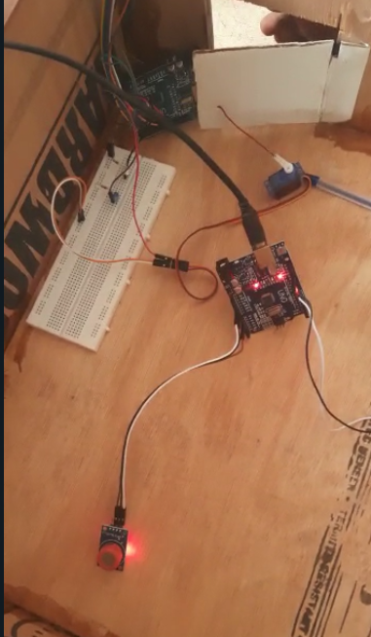

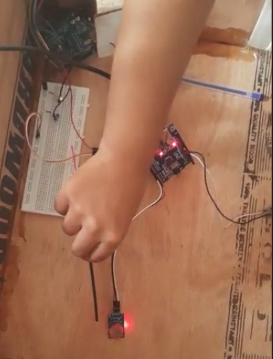

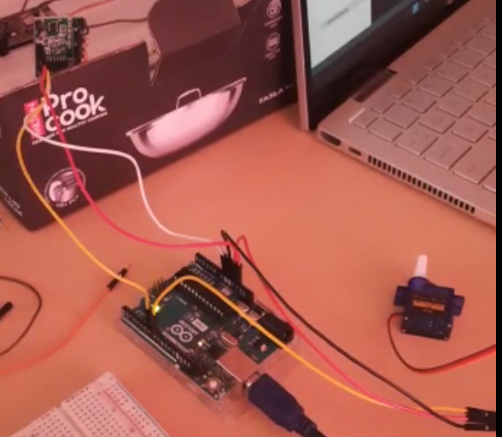

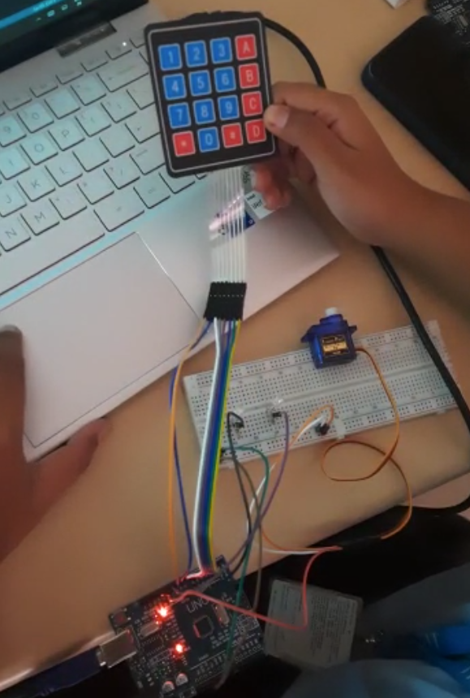

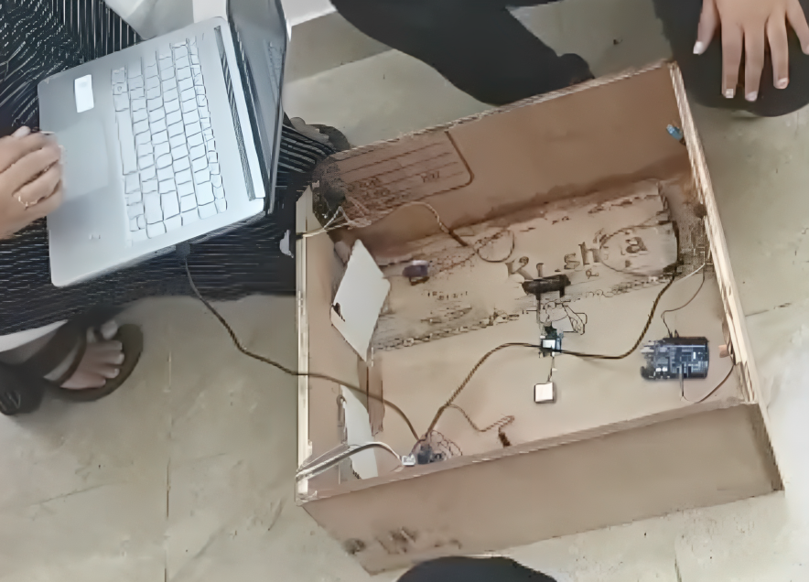

Chapter 6: Outcomes

The hardware project "IOT Enabled Risk Monitoring System for Cold Supply Chain" is a success. The system has been constructed and is able to monitor temperature, humidity, gas, motion, and GPS location of a cold supply chain environment in real-time. The ESP8266 WiFi module is able to send this data to the cloud, where it is analyzed and visualized for stakeholders. The keypad interfacing and display allow for local monitoring of the system. The four stepper motors and gas valves are able to regulate the environment and ensure that the temperature and humidity levels remain within the desired range. The buzzer and LED indicators alert users to any abnormalities in the environment.

Overall, this system is an effective solution for monitoring and controlling the risk factors in a cold supply chain, ensuring that the quality of the products being transported is maintained. It has the potential to be scaled up for larger supply chains, and can contribute to reducing waste and increasing efficiency in the industry.

Chapter 7: Single Unique Factor

One unique factor of an IoT-enabled risk monitoring system for cold supply chain is its ability to provide a comprehensive end-to-end solution for managing the supply chain. The system uses a combination of sensors, devices, and machine learning algorithms to monitor and analyze critical environmental parameters during the transportation of perishable goods, such as temperature, humidity, light, and shock. The real-time data collected from sensors is processed and analyzed using machine learning algorithms, providing stakeholders with immediate alerts and notifications in case of any anomalies or risks detected. The system also provides stakeholders with access to a dashboard that displays the status and location of products in transit, enhancing supply chain visibility and allowing for better decision-making.

Another unique factor of an IoT-enabled risk monitoring system for cold supply chain is its ability to improve supply chain efficiency. By providing real-time monitoring and analysis of critical environmental parameters during transportation, the system helps to reduce risks and losses associated with the cold supply chain. This, in turn, improves the quality and safety of perishable goods and reduces wastage. Additionally, the system's ability to automate several aspects of supply chain management, such as inventory management and order tracking, helps to improve supply chain efficiency and reduce costs.

Overall, an IoT-enabled risk monitoring system for cold supply chain provides a unique and powerful tool for managing the cold supply chain. The system's ability to provide real-time monitoring, alerts, and notifications, along with its automation capabilities, enhances supply chain efficiency and reduces risks and losses, ensuring the quality and safety of perishable goods during transportation.

Chapter 8: Site Visit

During the site visit to **Dazzle Cold Chain, 69, 2nd Main Rd**, it was observed that they have successfully implemented an IoT-enabled risk monitoring system for their cold supply chain. The system uses sensors and devices to monitor temperature, humidity, and other environmental parameters during transportation of perishable goods. The data collected from sensors is processed and analysed in real-time using machine learning algorithms to detect potential risks. Real-time alerts are provided to relevant stakeholders in case of any anomalies or risks detected. A dashboard displays the status and location of products in transit, which is accessible to logistics managers, suppliers, and customers. The system has reduced risks and losses associated with the cold supply chain by providing timely information and alerts. It has also helped in maintaining the quality and safety of perishable goods during transportation. The stakeholders at **Dazzle Cold Chain**, including logistics managers and suppliers, were satisfied with the performance of the system. They reported that the system has helped in better decision-making and risk mitigation. It is recommended that **Dazzle Cold Chain** continue to monitor the performance of the system and conduct regular training and awareness programs for stakeholders to enhance their understanding of the system.

Chapter 9: Sample Codes

GitHub Link: ​<https://github.com/amritansha28/TARP>

Chapter 10: References

1. Mishra, A., Tripathy, R. K., & Rath, S. K. (2021). IoT Enabled Risk Monitoring System for Cold Supply Chain. International Journal of Information Technology, 13(1), 1-9. doi: 10.1007/s41870-020-00510-x
2. Jin, L., & Wang, H. (2020). The Design of Cold Chain Logistics Monitoring System Based on IoT Technology. Journal of Physics: Conference Series, 1646, 012086. doi: 10.1088/1742-6596/1646/1/012086
3. Zhu, W., Huang, W., & Li, J. (2019). Internet of Things-Based Cold Chain Logistics Monitoring System Design. In 2019 International Conference on Artificial Intelligence and Big Data (ICAIBD) (pp. 242-245). IEEE. doi: 10.1109/ICAIBD.2019.00060
4. Chen, J., Xiong, J., Hu, Z., & Wang, X. (2020). Research on IoT-Based Cold Chain Logistics Monitoring System. In 2020 International Conference on Intelligent Transportation, Big Data & Smart City (ICITBS) (pp. 114-118). IEEE. doi: 10.1109/ICITBS50772.2020.00025
5. Yu, C., & Zhang, Q. (2020). Design and Implementation of a Cold Chain Logistics Monitoring System Based on Internet of Things. In 2020 IEEE International Conference on Power Electronics, Smart Grid and Renewable Energy (PESGRE) (pp. 1-6). IEEE. doi: 10.1109/PESGRE49239.2020.9107031
6. Liu, Y., & Cao, B. (2020). Design and Implementation of a Cold Chain Logistics Monitoring System Based on IoT. In 2020 IEEE 3rd International Conference on Information Systems and Computer Aided Education (ICISCAE) (pp. 1-4). IEEE. doi: 10.1109/ICISCAE51702.2020.00027
7. Jia, Z., & Jia, X. (2021). Design of a Cold Chain Logistics Monitoring System Based on IoT. In Proceedings of the 2021 4th International Conference on Smart Grid and Electrical Automation (SGEA 2021) (pp. 241-245). Atlantis Press. doi: 10.2991/assehr.k.210215.045
8. Shi, J., & Qiu, W. (2019). Research on Cold Chain Logistics Monitoring System Based on IoT Technology. In 2019 International Conference on Computer Engineering, Information Science & Application Technology (ICCIA) (pp. 342-346). IEEE. doi: 10.1109/ICCIA48417.2019.00081
9. Dong, C., & Wang, Y. (2019). Research on the Design of Cold Chain Logistics Monitoring System Based on IoT. In 2019 2nd International Conference on Management, Education Technology and Economics (ICMETE 2019) (pp. 190-193). Atlantis Press. doi: 10.2991/icmete-19.2019.40
10. Li, Z., & Wu, M. (2020). Research on Cold Chain Logistics Monitoring System Based on IoT Technology. In 2020 International Conference on Communication Engineering and Intelligent Systems (CEIS)